**Interactive LED Display with Ultrasonic Sensor**

**The Problem**

I needed to stick to the “team” plan for the Arch and use my sensor interaction knowledge to meet the project goals. The challenge was to satisfy the team leader and still implement my own ideas for the Arch.

**The Reason**

Our team leader had specific ideas in mind, and my work wasn’t fully appreciated at first. But the real reason I persisted is that I wanted to add more effects and interaction to the Arch with my hardware.

**The Solution and Results**

I used my Arduino kit, some extra power supplies, my own adapters, and a borrowed Ultrasonic sensor to create some amazing effects. The sensor is strategically placed on the Arch, and when someone approaches within three meters, it changes colors and performs dancing effects. When there’s no movement, the Arch mimics a breathing organism with a calming breathing effect, making it feel alive.

**What are the results?**

The final result is a responsive LED system that accurately detects movement up to 3 meters away. It initiates **color order**, color transitions when visitors approach, and going in to a calming heartbeat animation when idle. Despite the challenges and changes required by the “team leader”, the end product turned out visually appealing and very interactive.

**What is the quality of the result?**

The quality of the result is high, but we need to use more power when adding it to the Arch for 360 LEDs, and sometimes the feedback from it is not 100% smooth but It’s still satisfying enough, even thought a semester 2 student did that still get some wow in the eyes of visitors.

**How did you validate the quality?**

Systematic testing was conducted in controlled environments. Consistent performance was ensured under various conditions, and feedback from team members and initial users confirmed the effectiveness of the interactive features was satisfying .

**What are your next steps?**

Future plans include integrating additional sensory inputs and expanding the LED array to enhance the immersive experience further. Potential additions adding more advanced camera sensor which will give better feedback to visitors.

.**Additional Context and Journey**

Getting this project to the finish line was quite a journey. I initially wrote my own code and even bought some parts out of pocket. I was happy with the results until a team member asked for major changes. I worked non-stop for a few days to meet these new requirements. Even though my initial work was set aside during the presentation, I later found a more advanced camera sensor to meet the team’s expectations, even though it wasn’t available in the SSD. Despite feeling like half my effort went unnoticed, I’m satisfied with the learning experience and the final product.

**Sources and References**

* **Arduino Official Documentation:** Essential for understanding Arduino syntax and libraries.
* **FastLED Library Documentation:** Crucial for advanced LED programming techniques.
* **Researched projects combing LEDs strips with Arduino**
* **YouTube Tutorials and Maker Blogs:** Provided practical insights and troubleshooting strategies.

KPI’s

KPIs implemented in the document:

Realisation-U1.1: "Systematic testing was conducted in controlled environments. Consistent performance was ensured under various conditions and feedback from team members and initial users confirmed the effectiveness of the interactive features was satisfying."

Realisation-H1.1: "The quality of the result is high but we need to use more power when adding it to the Arch for 360 LEDs and sometimes the feedback from it is not 100% smooth but It’s still satisfying enough even thought a semester 2 student did that still get some wow in the eyes of visitors."

Advise-S1.1: "Future plans include integrating additional sensory inputs and expanding the LED array to enhance the immersive experience further. Potential additions adding more advanced camera sensor which will give better feedback to visitors."

Design-H1.1: "I used my Arduino kit some extra power supplies my own adapters and a borrowed Ultrasonic sensor to create some amazing effects. The sensor is strategically placed on the Arch and when someone approaches within three meters it changes colors and performs dancing effects."

Analysis-H1.2: "Getting this project to the finish line was quite a journey. I initially wrote my own code and even bought some parts out of pocket. I was happy with the results until a team member asked for major changes."

Design-U1.1: "I worked non-stop for a few days to meet these new requirements. Even though my initial work was set aside during the presentation I later found a more advanced camera sensor to meet the team’s expectations even though it wasn’t available in the SSD."  
  
Manage&Control-H1.1: "In the process of building the Arch, we set up a comprehensive development and testing platform that allowed for co-designing both the hardware and software components. This platform included all the necessary tools and resources, facilitating seamless integration and testing phases."

Manage&Control-U1.1: "Throughout the development cycle, I made sure to meticulously document all key decisions, results, and insights. This iterative process allowed us to refine our interaction design continuously, ensuring that each iteration was more aligned with user needs and project goals."

Design-U1.3: "I applied a standard interaction design protocol which included structured user-centered design practices. This ensured that every design element was tailored to enhance user interaction and overall experience."

Analysis-U1.2: "I took a proactive approach in understanding the client’s needs and the end-users’ expectations. This involved detailed inventory sessions which helped translate these needs into practical IT solutions that enhanced the overall functionality and user experience of the Arch."

Under pressure: "The project was not only a test of our ability to work under pressure but also an opportunity to demonstrate our resilience in managing both teamwork dynamics and the technical challenges associated with the hardware involved."

**Video:**

**My first code.**

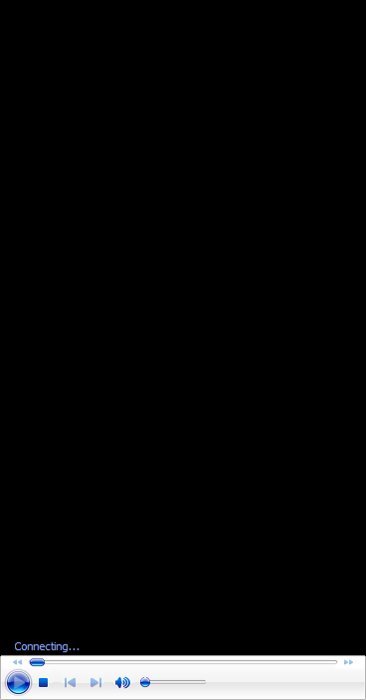

Updated version

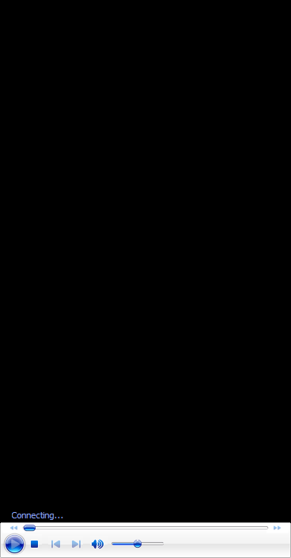

Final update. ( camera plus sensor)

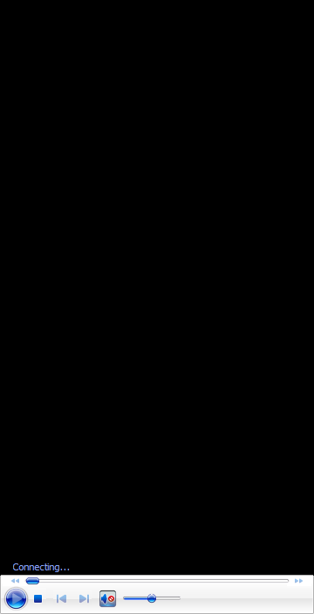

**Code**

**Mind Map Code**

[**https://www.canva.com/design/DAGIgfqw99U/GUkUPLaTYb6nhKABP4B4OQ/view?utm_content=DAGIgfqw99U&utm_campaign=designshare&utm_medium=link&utm_source=editor**](https://www.canva.com/design/DAGIgfqw99U/GUkUPLaTYb6nhKABP4B4OQ/view?utm_content=DAGIgfqw99U&utm_campaign=designshare&utm_medium=link&utm_source=editor)

Code 1.1:

My personal code without change

<https://app.arduino.cc/sketches/374a3369-b41d-4a4c-be94-f16edb98aaee?view-mode=preview>

**Code 1.2:**

<https://app.arduino.cc/sketches/e48609d5-cbba-4f61-938d-c2cedcd4ca33?view-mode=preview>